DA SILVA
ACADEMY

Physical Address
212 Klopper Street,
Rustenburg
0299
Rustenburg
Fax / Office Tel: (014) 592 5613
E-Mail : dasilvaacademy@gmail.com
EMIS: 600105372

Dear Parents 31 July 2017

2018 Stationary Information

There will be options available to the parents as to purchasing the learner’s stationary. The school has VERY LIMITED books and stationary available. The options are as follows:

- R1900.00 package (Textbooks, stationary, school bag and pencil bag. If there are any items finished or lost before the end of the year, it is the parents responsibility to replace the items.
- Textbooks and stationary can be purchased separately.
- Textbooks and stationary may be purchased by outside providers. (Textbooks can be purchased by Bargain Books or The Inkpot)

It is of utmost importance that the learner’s stationary is here on the first day of school in 2018. Learners who do not have the required textbooks and stationary will not be able to borrow from their peers.

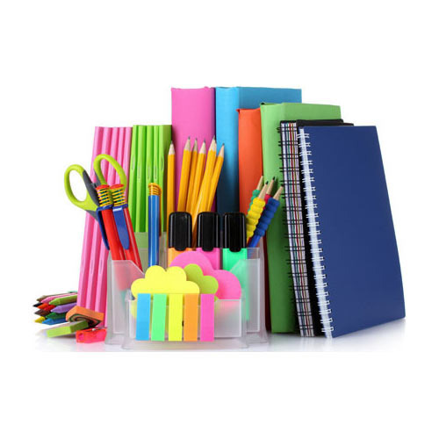
Please see the following pages of the textbooks and stationary list and order form. If you wish to order from the school the order form is to be sent back with proof of payment attached by the 29 September 2017.

Kind Regards,
Mrs. M. Silva

Text Books | Grade | Price | Order Quantity
Day by Day Life skills Activity book | R | R70
Bluebird My Activity Book -Learners workbook | R | R110
Bluebird My Handwriting Book -Learners workbook | R | R110
Spot on Grade R Learners workbook | R | R100
Day by day Numeracy Activity book | R | R70
10 Stars workbook | R | R80
Platinum Mathematics | 1 | R100
Platinum English Home Language | 1 | R120
Afrikaans Sonder Grense | 1 | R110
Platinum FAL English | 1 | R110
Day by Day Life Skills | 1 | R90
Spot on Maths | 1 | R90
Platinum Mathematics | 2 | R100
Platinum English Home Language | 2 | R130
Afrikaans Sonder Grense | 2 | R120
Platinum FAL English | 2 | R120
Day by Day Life Skills | 2 | R90
Spot on Maths | 2 | R90
Platinum Mathematics | 3 | R110
Platinum English Home Language | 3 | R140
Afrikaans Sonder Grense | 3 | R130
Platinum FAL English | 3 | R120
Day by Day Life Skills | 3 | R100
Spot on Maths | 3 | R100
Learning Material 2018 | 1-7 | R1900
School bag with Logo | All Grades | R250
Platinum Mathematics | 4 | R140
Platinum English Home Language | 4 | R150
Platinum N.S and Technology | 4 | R130
Platinum Social Science | 4 | R140
Afrikaans Sonder Grense | 4 | R160
Day by Day Life Skills | 4 | R130
Platinum Mathematics | 5 | R140
Platinum English Home Language | 5 | R150
Platinum N.S and Technology | 5 | R140
Platinum Social Science | 5 | R140
Afrikaans Sonder Grense | 5 | R150
Day by Day Life Skills | 5 | R130
Platinum Mathematics | 6 | R150
Platinum English Home Language | 6 | R160
Platinum N.S and Technology | 6 | R140
Platinum Social Science | 6 | R140
Afrikaans Sonder Grense | 6 | R160
Day by Day Life Skills | 6 | R140
Platinum Mathematics | 7 | R170
Oxford English for Success | 7 | Out of stock | Out of stock
Platinum Natural Science | 7 | R160
Platinum Social Science | 7 | R170
Afrikaans Sonder Grense | 7 | R160
Spot On Life Orientation | 7 | R160
Platinum Mathematics | 7 | R170
Platinum Creative Arts | 7 | R170
Platinum Technology | 7 | R160
Spot On EMS | 7 | R170

Stationary Price List for 2018
Description | Price | Quantity
A5 72 pg Feint Ruled exercise | R4.00
A4 72 pg Feint Ruled College Exercise | R6.00
A4 72 pg Quad Ruled College Exercise | R6.00
A4 72 pg Unruled College Exercise | R6.00
A5 96 pg Hard Cover Feint Ruled | R10.00
A4 1 Quire 96 pg Hard Cover Feint Ruled | R16.00
A4 2 Quire 192 pg Hard Cover Feint Ruled | R24.00
Drawing Book A3L 32 pg Interleaved/tissue | R22.00
Sketch Pad A4L 25 sheet | R20.00
Exam Pad A4 100 Sheets Punched | R16.00
Glue Stick - large | R20.00
Ballpoint Pen – blue ink | R5.00
Eraser | R5.00
Staedtler Tradition 110 Pencils HB (Box12) | R25.00
Pencil HB | R3.00
Pencil 2B | R3.00
Pencil Crayons full size – Set 12 | R25.00
Retractable Wax Crayons- Set 12 | R40.00
Atlas | R160.00
Dictionary | R70.00
Wax crayons (box of 12) | R25.00
EL231L Sharp Basic 4 Function Calculator | Out Of Stock
Ruler - 30cm | R5.00
Student scissors | R20.00
Pencil Sharpener | R6.00
A4 Flip File – 20 pocket | R30.00
Croxley Maths Set (10 piece) | R50.00
Abacus | R80.00
Pentel Oil Pastels (Box of 16) | R50.00
Tissues (pack 100) | Out Of Stock
Jumbo Coloring Activity Book | R40.00
Ream of A4 White paper-Typek; 80gram | R65.00
Ponal Wood Glue | R25.00
A4 Hard Plastic Covers (Pkt 5) | Out Of Stock
Cello tape (clear) | R5.00
Tennis balls (old/new) | Out Of Stock

Child’s Name and Surname: ___________________________________________________________
Grade for 2018: ______________________ Total Amount: _________________________________
Proof of payment attached: _________________________________________
Banking details: Standard Bank - Da Silva Academy, Account number: 370681053, Barongwa Branch, Reference: (TB2018 /Childs name and surname)

