Da Silva’s Scoop

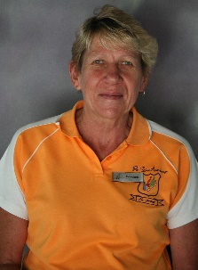

From the Principals Desk
Dear Parents,
The Winter season is upon us, please make sure that your child has the correct Winter uniform.
Please note that school officially starts at 07:15 for Intermediate phase and Grade 3, and 7:30 for Foundation phase each morning. Quite a few children come in late every morning, which is disruptive to the day. They tend to miss the morning briefing and messages as well as being on the back-foot, in that they feel rushed and under pressure from the moment that they arrive on the school property. Time keeping is a life-skill and something that we need to instill in our children from an early age.
Rehearsals are now well under way for the upcoming school concert “Feel the beat”, which will be on the 3rd November 2017 at the Civic Centre. Already the energy and excitement at practices is palpable.
School will be closing THIS Friday 30 June 2017 at 11:00am for the WHOLE school. School re-opens on Monday 24 July 2017 for the Third Term. Have a lovely winter break.
Yours Sincerely,
Mrs. A. van der Berg.
Head of Academics (Grade 1- Grade 7)
Dear Parents,
Term 2 is nearly at the end and a well-deserved winter holiday starts on Friday 30 June 2017. All Foundation phase learners (Grade 1-Grade 3) have completed their Mid-Year Assessments. Intermediate phase learners will be done tomorrow and the Senior phase will be done on Wednesday. A big thank you to all parents that have helped the learners to prepared for these assessments and examinations. These were very important assessments and examinations.
There will be parents evening next term for all learners and Grades. Please take note of the dates in the program. I encourage all parents to please attend the parents evening as it is important to be aware of the learner’s progress in the academics.
Thank you to all the daddies that attended the Grade 3 Dad’s, Lad’s and Ladies Soccer tournament in celebration of Father’s Day. The daddies and the children enjoyed the time spent together thoroughly!
May we all have a lovely winter break and well rested for Term 3.
*Download the Da Silva Academy App from the app store.*
Yours sincerely,
Miss Hautmann
Head of Pre-Primary (Grade 0-Grade R)
Dear Parents,
I would like to thank all the mothers who took their precious time off to come and enjoy the Mother’s Day tea with us. It was a very successful event and we will surely do it again in future.
The Grade R learners had lots of fun on the trip they took to Giddy Up Farm on Thursday the 22nd June 2017. They were taught about animals, for example: what they eat and how to keep them clean. They also took turns to ride on the horses and to feed some of the animals. It was a memorable experience indeed.
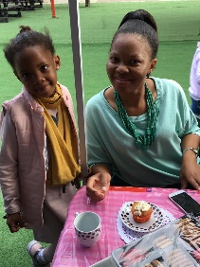
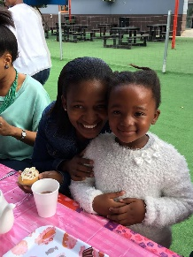
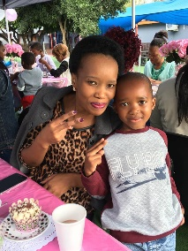
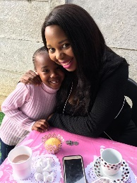
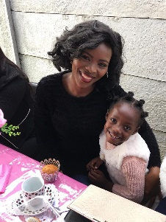
Thank you to all parents who are fully involved in their child’s education. We truly appreciate it.

Yours Sincerely,
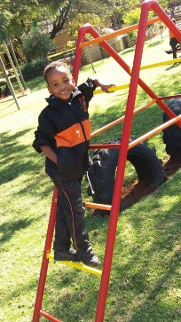
Miss Novela
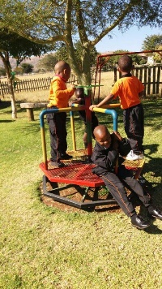
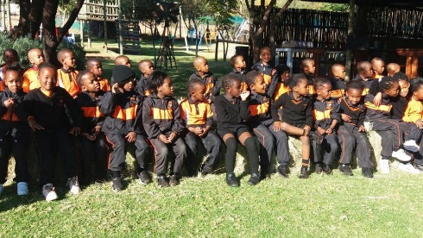

Head of Sports

Dear Parents,
We have had a very successful Term 2. Our Soccer and netball teams have had their first matches.
We had netball and soccer matches against Cornerstone Primary school on Friday 26 May 2017.
The U/8 soccer team had a match on Saturday 3 June 2017 against the Sporting Soccer Academy.
The Netball girls had a match against Noble Palms on 06 June 2017. They won their first game 4-1 and their second game was a tie.
In the third term, the hockey girls will be having their first match against Noble Palms. We wish our learners good luck and have fun.
All Learners have received their sports kit, which is only to be worn for matches and need to be looked after.
It is very important that all learners attend their practices in the afternoon as they need to be ready for matches.
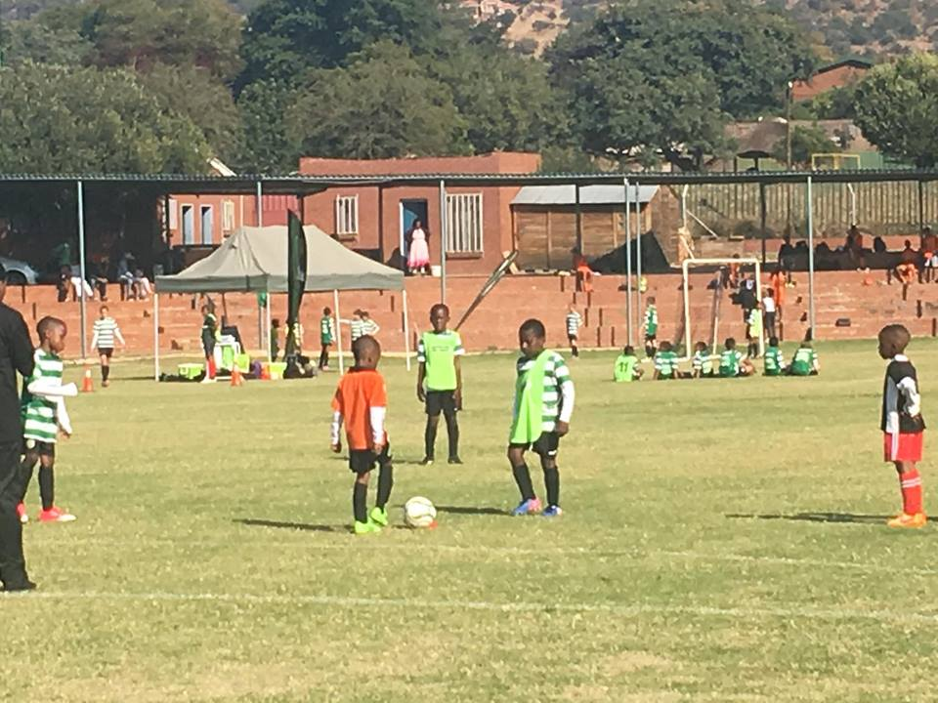
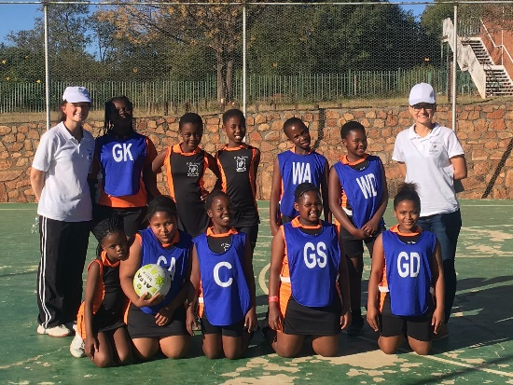
Have a wonderful holiday and if travelling please be safe.
Yours sincerely,
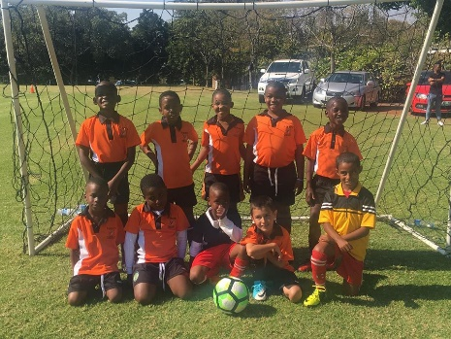
Miss. B. Grobbelaar

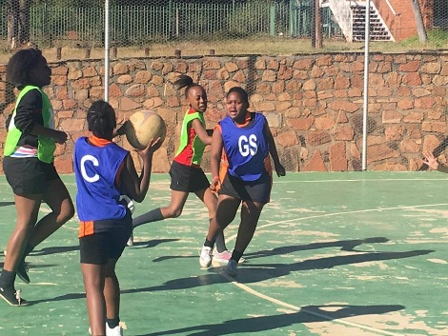
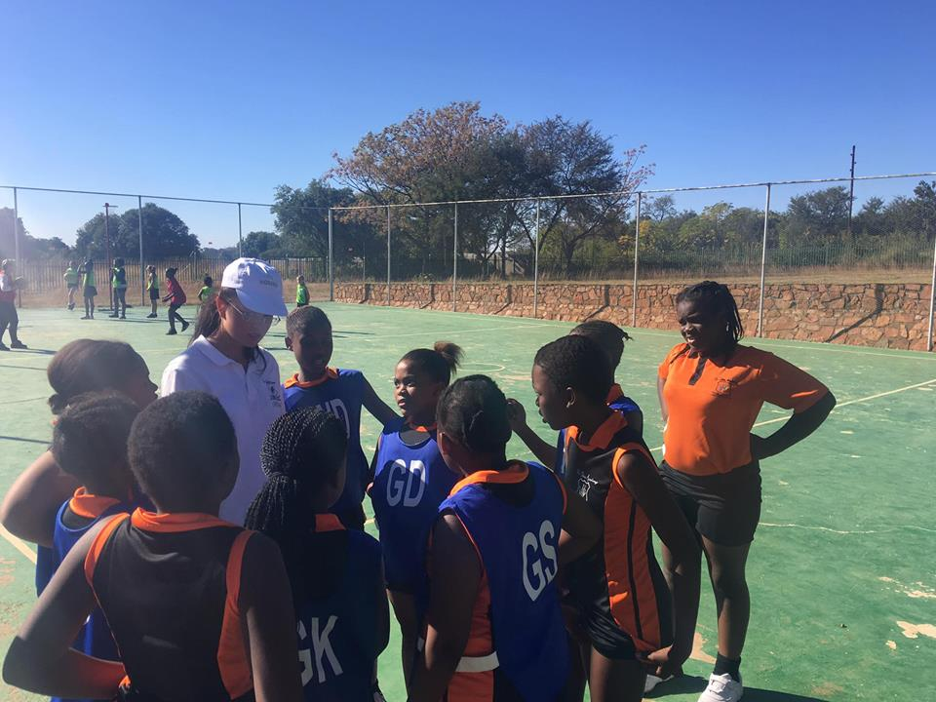
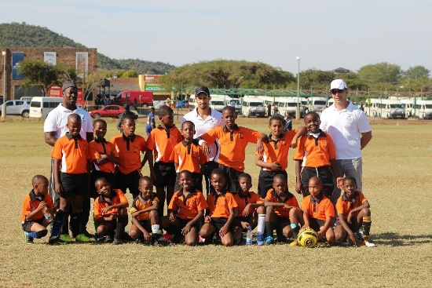

Program for June/July 2017
N.B- Please take note of the following dates and activities:
Date | Day | Activity | Additional Information
27 June 2017 | Tuesday | Intermediate Mid-Year Examination | Intermediate Mid-Year Examination finish
30 June 2017 | Friday | SCHOOL CLOSES | School will close at 11:00am for the WHOLE school for Term 2.
24 July 2017 | Monday | School Opens | School opens for Term 3.
25 July 2017 | Tuesday | Grade 1 Parents Evening | Parents evening for Grade 1 parents from 16:00-17:00
26 July 2017 | Wednesday | Grade 2 Parents Evening | Parents evening for Grade 2 parents from 16:00-17:00
26 July 2017 | Wednesday | Grade 00 Outing | Grade 00 Third Term Outing
27 July 2017 | Thursday | Grade 3 Parents Evening | Parents evening for Grade 3 parents from 16:00-17:00
28 July 2017 | Friday | Grade 4, 5, 6 and 7 Parents Evening | Parents evening for Grade 4, 5, 6 and 7 parents from 16:00-17:00
01 August 2017 | Tuesday | Grade 00 and Grade R parents evening | Parents evening for Grade 00 and Grade R parents from 16:00-17:00

